Software Requirements Specification
for the
University Conference Center System
-Project 1-
Version 0.1 approved
Prepared by Thomas Behner, Cameron Haught, Jacob Forte
Group 2
4/30/2017
Table of Contents
Table of Contents ii
Revision History ii
1. Introduction 1
1.1 Purpose 1
1.2 Document Conventions 1
1.3 Intended Audience and Reading Suggestions 1
1.4 Product Scope 1
1.5 References 1
2. Overall Description 2
2.1 Product Perspective 2
2.2 Product Functions 2
2.3 User Classes and Characteristics 2
2.4 Operating Environment 2
2.5 Design and Implementation Constraints 2
2.6 User Documentation 2
2.7 Assumptions and Dependencies 3
3. External Interface Requirements 3
3.1 User Interfaces 3
3.2 Hardware Interfaces 3
3.3 Software Interfaces 3
3.4 Communications Interfaces 3
4. System Features 4
4.1 System Feature 1 4
4.2 System Feature 2 (and so on) 4
5. Other Nonfunctional Requirements 4
5.1 Performance Requirements 4
5.2 Safety Requirements 5
5.3 Security Requirements 5
5.4 Software Quality Attributes 5
5.5 Business Rules 5
6. Other Requirements 5
Appendix A: Glossary 5
Appendix B: Analysis Models 5
Appendix C: To Be Determined List 6

Introduction

Purpose
The purpose of the University Conference Center System (UCCS) is to manage the registration and scheduling of conferences at the University Conference Center (UCC). It is intended to be a fully automated system that can monitor conference resources (i.e., audio/visual equipment) and keep a record of previous conferences to facilitate business forecasting.

Document Conventions
Various acronyms can be found in this document. The acronym for each term will be found in a set of parenthesis following the term to be abbreviated

Intended Audience and Reading Suggestions
This document is currently intended for the development team working on the UCCS, and the organization for which the software is being developed (the UCC). As of this writing (3/2/17), the document can be read in the usual fashion, start to finish

Product Scope
The UCCS will handle the registration and scheduling of conferences at the UCC. To enhance the scope of an automated system, the UCCS will keep an inventory of needed conference equipment and schedule necessary maintenance.

References
<List any other documents or Web addresses to which this SRS refers. These may include user interface style guides, contracts, standards, system requirements specifications, use case documents, or a vision and scope document. Provide enough information so that the reader could access a copy of each reference, including title, author, version number, date, and source or location.>

Overall Description

Product Perspective
The system developed had the goal in mind of allowing various organizations to create conferences and then allow would-be attendees to sing-up for said conferences. The UCC currently had no such system in place in any regard, so this was a build-from-the-ground up sort of system. It is fully self contained, as in there are no smaller systems that will directly play into it, and it is the full package, as in there is not some larger system that the UCCS plays a role in.

Product Functions
- Register a conference- reserve rooms, equipment, guest space, etc
- Register a guest into a conference
- Keep track of regular and special sessions
- Prepare schedule of all sessions in a conference
- Prepare schedule of all conferences in a season
- Maintain an inventory of A/V equipment available for conferences
- Calculate cost of each conference based on attendance/rooms and equipment used
- Bill each organization and conference attendee based on the cost accrued for registration

User Classes and Characteristics
- Organizations- any entity (business, organization, person, etc.) looking to create a conference through the UCC
- Attendees- any individual looking to attend a conference held by the UCC
- Admin- special users denoted by the UCC to have the power to manually alter the database [functionality to be added at a future date]

Operating Environment
The furthest extents of the operating environments(s) are unknown.

Design and Implementation Constraints
As of this date, there are no listed design or implementation constraints.

User Documentation
Since the functionality is relatively simplistic, it will be listed here instead of included in another document:

The entire system is explicitly straightforward. Follow the prompted directions on the screen after booting up the system. Users that fall into the Attendees user class should either create or sign in as an attendee, and user that fall into the Organizations user class should either create or sign in as an organization.

Further implementation for administration usage is to be included at a future date.

Assumptions and Dependencies
As of this date, there are no listed assumptions or dependencies

External Interface Requirements

User Interfaces
Below is the sample interface the user will encounter upon starting up the system. This is the GUI that will allow users to sign in as their proper user class and access all the necessary functions for their user class. The user may also create an account fitting for their user class if an account does not already exist.

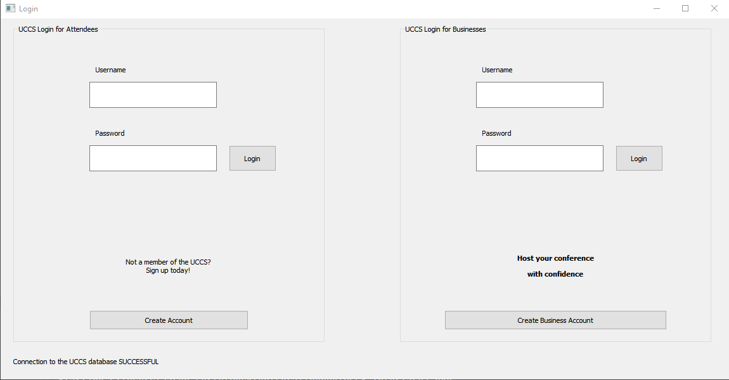
Below is the sample interface the user will see if they wish to create a business account.

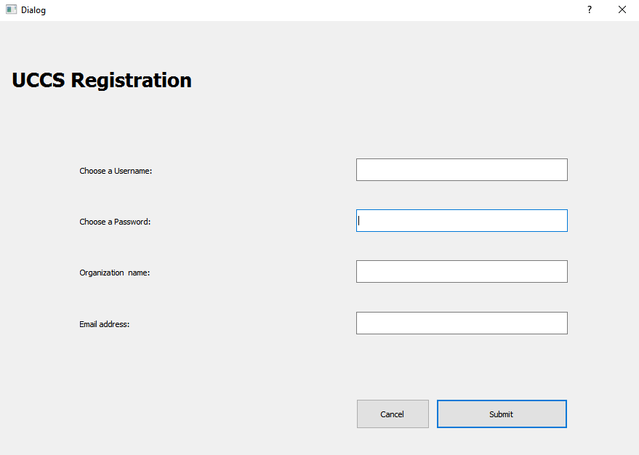
Below is the sample interface the user will see if they wish to create an attended account.

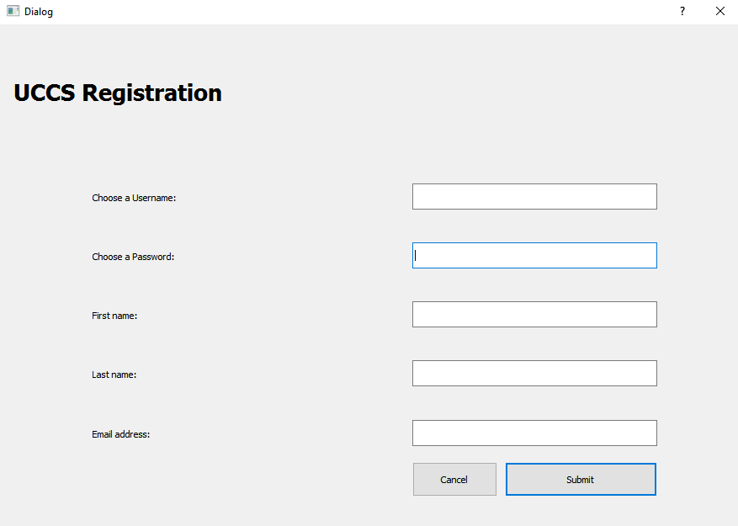
Below is the sample interface the user will see if they are logged in as a business account.

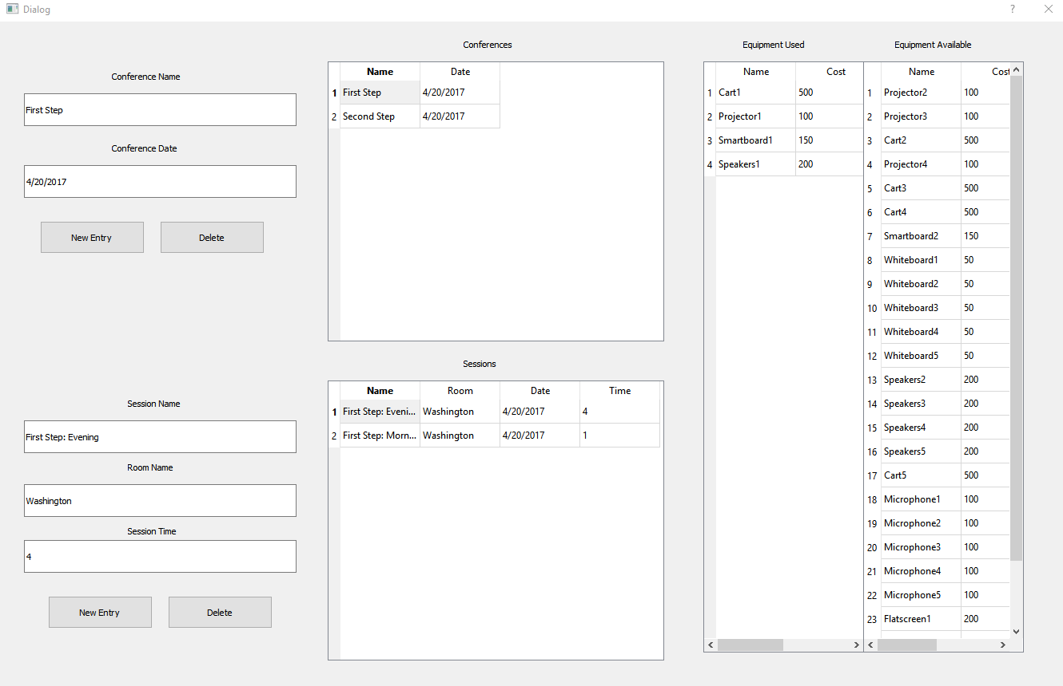
Below is the sample interface the user will see if they are logged in as an attendee account. It may be relatively plain. We had to cut this UI short due to time restraints.

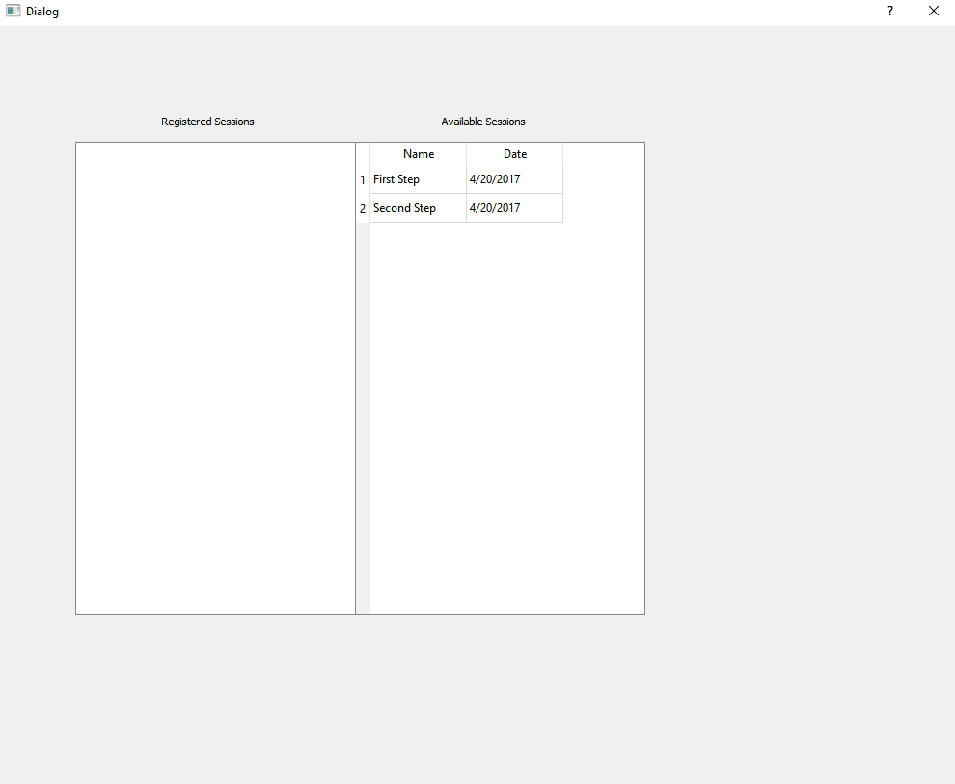

Hardware Interfaces
The currently implemented version of the system is a step up from a console application meant to be run any given machine, provided it has the necessary software for the program.

- A Qt UI frontend
- SQLITE Database backend

Communications Interfaces
The system currently only needs access to the SQLITE DB and any required DLLs. These can be handled by having relevant files in the root off the program

System Features

Create a Conference
4.1.1 Description and Priority
Allow an organization to create a conference. High priority

The Business simply must enter the required data in the text fields of the interface
4.1.2 Stimulus/Response Sequences
An organization logs in to the system. The system then guides the user through various prompts that allow for the creation of a conference, such as a prompt to request various resources for a given session or the ability to mark a session as being special.

4.1.3 Functional Requirements

REQ-1: Provided DLLs in the root of the .exe
REQ-2: the SQLITE.db file in the root of the .exe

Register for a Conference
4.2.1 Description and Priority
Allow a guest to register as an attendee for any given conference.
4.2.2 Functional Requirements
REQ-1: Provided DLLs in the root of the .exe
REQ-2: the SQLITE.db file in the root of the .exe
Create an Account
4.1.1 Description and Priority
Allows a user, upon interacting with the system, to create an account with the system (an account is required to access any of the system’s other functionalities). This encompasses both user user classes- organization and attendee.
4.1.2 Stimulus/Response Sequences
At the login in page, a user with no previous account will be prompted to create an account. All necessary information for creating an account will be requested, and upon entering such information, the account will be available to log in to.
4.1.3 Functional Requirements
REQ-1: Provided DLLs in the root of the .exe
REQ-2: the SQLITE.db file in the root of the .exe

Other Nonfunctional Requirements

Performance Requirements
None

Safety Requirements
None

Security Requirements
None

Software Quality Attributes
None

Business Rules
Only the purchasing business can use this software. User without permission is against TOS

Other Requirements
There are currently no other requirments.
Appendix A: Glossary
SQLITE: A local Database
Qt: a ui front end
Appendix B: Analysis Models
All necessary analysis models have been released already as part of the project’s creation.

